**Level 3**

**PROMPT sheet**

**3/1 Place value**

The position of the digit gives its size

|  |  |  |  |  |  |  |
| --- | --- | --- | --- | --- | --- | --- |
| thousands | hundreds | tens | units | . | tenths | hundredths |
| 4 | 3 | 5 | 2 | . | 6 | 1 |

Example

The value of the digit ‘4’ is 4000

The value of the digit ‘3’ is 300

**3/2 Recognise negative numbers**

* **These can be seen on a thermometer**

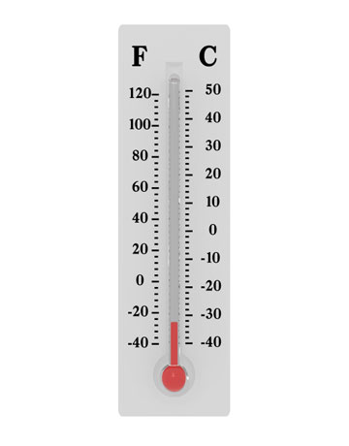

The numbers below freezing (00) are negative

* **Number line to work out sums**

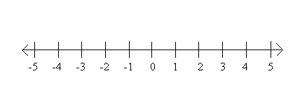

**3 – 5 = -2**

**3/3 Multiples**

* **Multiples are the number sequences that make up the tables**

Example

The multiples of 2 are:

2 4 6 8 10 ...

The multiples of 5 are:

5 10 15 20 25 ...

The multiples of 10 are:

10 20 30 40 50 ...

**3/4 Fractions**

numerator

denominator



* **This means 1 part out of every 2**

Example 1



=

These fractions are all ½

Example 2



* **This means 2 part out of every 3**



=

**3/5 Decimals**

* **Decimals and money**

£3.00 means 300p

£3.50 means 350p

£3.05 means 305p

**Remember**

A calculator does not know if the numbers you put in are money so £3.50 will look like 3.5

* **Ordering Decimals**

1.23 m 1.6 m 1.65 m 1.3 m

1.23 m 1.60 m 1.65 m 1.30 m

Make the number of digits the same, it is easier to order them

Smallest Largest

1.23 m 1.30 m 1.60 m 1.65 m

**3/6 Know the 3, 4 and 6 times tables**

|  |  |  |  |  |
| --- | --- | --- | --- | --- |
| 1 | x | 3 | = | 3 |
| 2 | x | 3 | = | 6 |
| 3 | x | 3 | = | 9 |
| 4 | x | 3 | = | 12 |
| 5 | x | 3 | = | 15 |
| 6 | x | 3 | = | 18 |
| 7 | x | 3 | = | 21 |
| 8 | x | 3 | = | 24 |
| 9 | x | 3 | = | 27 |
| 10 | x | 3 | = | 30 |

|  |  |  |  |  |
| --- | --- | --- | --- | --- |
| 1 | x | 4 | = | 4 |
| 2 | x | 4 | = | 8 |
| 3 | x | 4 | = | 12 |
| 4 | x | 4 | = | 16 |
| 5 | x | 4 | = | 20 |
| 6 | x | 4 | = | 24 |
| 7 | x | 4 | = | 28 |
| 8 | x | 4 | = | 32 |
| 9 | x | 4 | = | 36 |
| 10 | x | 4 | = | 40 |

|  |  |  |  |  |
| --- | --- | --- | --- | --- |
| 1 | x | 6 | = | 6 |
| 2 | x | 6 | = | 12 |
| 3 | x | 6 | = | 18 |
| 4 | x | 6 | = | 24 |
| 5 | x | 6 | = | 30 |
| 6 | x | 6 | = | 36 |
| 7 | x | 6 | = | 42 |
| 8 | x | 6 | = | 48 |
| 9 | x | 6 | = | 54 |
| 10 | x | 6 | = | 60 |

**3/7 Division facts from a multiplication**

Any multiplication sum can be written as 2 division sums

14 x 5 = 70

70 ÷ 14 = 5 70 ÷ 5 = 14

**3/8 Balancing a sum**

**left hand side is equal to right hand side**

**3 x 4 = 12**

This can be used to find missing numbers

**3 x 4 = 3 +**

**12 = 3 + 9**

**So = 9**

**3/9 Add 2 digit numbers mentally**

Partitioning

**36 + 19**

**30 + 6 + 10 + 9 36 + 10 + 9**

**= 40 + 15 = 46 + 9**

**= 55 = 55**

**3/9 Subtract 2 digit numbers mentally**

**63 - 26**

Partitioning Counting on from 26

**63 – 20 – 6 (26) + 4 + 33**

**= 43 - 6 = 37**

**= 37**

**3/11 Solve problems**

* **When to multiply and when to divide**
* **When to round up and when to round down**

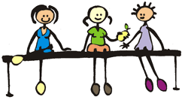**Here is an example**

There are 17 children in the playground.

Each bench in the yard can seat 3 children.

How many benches will be needed?

**17 ÷ 3 = 5 r 2**

* We need to divide to share the children around the benches
* We need to round up to 6 benches for the remaining 2

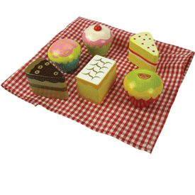**Here is another example**

Dan made 47 cakes.

He sells them in boxes of 6.

How many full boxes will we have?

**46 ÷ 6 = 7 r 4**

* He needs to divide to share the cakes into boxes
* He needs to round down to 7 boxes because he needs to have 6 cakes in each box

**3/12 Written method for addition**

* **Line up the digits in the correct columns**

e.g. 132 + 239 H T U

1 3 2

2 31 9 +

3 7 1

**3/12 Written method for subtraction**

* **Line up the digits in the correct columns**

e.g. 327 - 119 H T U

3 12 17

1 1 9 -

2 0 8

**3/13 Methods for multiplying**

38 x 3

**Column method**

3 8

2 3 x

1 1 4

**Grid method**

30 8

3 90 24

90 + 24 = **114**

**Partitioning method**

38 x 3

= 30 x3 + 8 x 3

= 90 + 24

= 114

**To multiply by 10**

Move all the digits along one place to the left. Remember to put a zero in the units.

|  |  |  |
| --- | --- | --- |
| H | T | U |
|  | 3 | 0 |
| 3 | 0 | 0 |
| 30 x 10 = 300 | | |

**3/13 Methods for dividing**

25 ÷ 3

8 x 3 = 24 So 25 ÷ 3 = 8 r 1

**To divide by 10**

Move all the digits along one place to the right.

|  |  |  |
| --- | --- | --- |
| H | T | U |
|  | 3 | 0 |
|  |  | 3 |
| 30 ÷ 10 = 3 | | |

**3/14 Classify 2D shapes**

A

B

C

D

E

Triangle Square Rectangle Parallelogram Trapezium

A

B

C

D

E

Reflective Reflective Reflective **NO** reflective Reflective

symmetry symmetry symmetry symmetry symmetry

**3/14 Classify 3D shapes**

Cube cuboid triangular prism cylinder sphere cone square-based

pyramid

All have a curved surface All are prisms – same shape through the length

Pyramids go to a point

**3/15 Nets of 3D shapes**

CUBE

CUBOID

SQUARE-BASED

PYRAMID

**3/16 Shapes in different orientations**

**These are the same shapes – just moved round**

**These shapes have been reflected – flipped over**

In a HORIZONTAL mirror line

|  |  |  |  |  |  |
| --- | --- | --- | --- | --- | --- |
|  |  |  |  |  |  |
|  |  |  |  |  |  |
|  |  |  |  |  |  |
|  |  |  |  |  |  |
|  |  |  |  |  |  |
|  |  |  |  |  |  |

In a VERTICAL mirror line

|  |  |  |  |  |  |
| --- | --- | --- | --- | --- | --- |
|  |  |  |  |  |  |
|  |  |  |  |  |  |
|  |  |  |  |  |  |
|  |  |  |  |  |  |
|  |  |  |  |  |  |
|  |  |  |  |  |  |

In a 450 mirror line

|  |  |  |  |  |  |
| --- | --- | --- | --- | --- | --- |
|  |  |  |  |  |  |
|  |  |  |  |  |  |
|  |  |  |  |  |  |
|  |  |  |  |  |  |
|  |  |  |  |  |  |
|  |  |  |  |  |  |

**3/17 Describe position and movement**

LEFT RIGHT

ANTICLOCKWISE CLOCKWISE

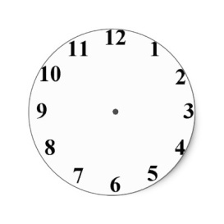

Clockwise 900 or ¼ turn



Anticlockwise 900 or ¼ turn



Half turn

**3/18 Use standard units**

MEASURES OF LENGTH

1cm = 10mm

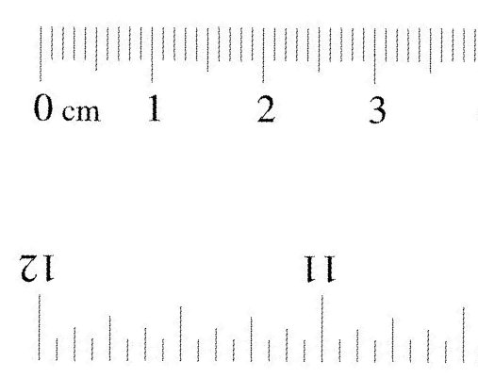

1 metre = 100cm

1 kilometre = 1000m

MEASURES OF WEIGHT

1 gram

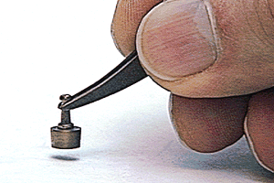

1kilogram = 1000g

MEASURES OF LIQUID(Capacity)

5 millilitre spoon



1 litre = 1000ml

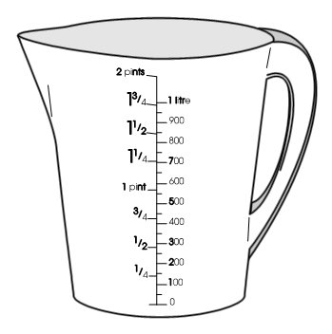

**3/19 Other units of measure**

PERIMETER is the distance round the outside of a shape

Perimeter of this shape = 12cm



AREA is the number of squares **INSIDE**

Areaof this shape = 5cm2



1

ANGLE is the amount of turn

This angle is 300

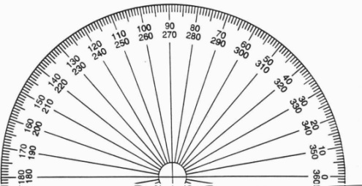

**3/20 Gather information**

To record the number of birds in the garden

|  |  |  |
| --- | --- | --- |
| Type of bird | Tally | Number of birds |
| Blackbird |  | 10 |
| Blue-tit |  | 4 |
| Starling |  | 2 |
| Sparrow |  | 3 |
| Other |  | 1 |

**3/21 Construct bar chart**

Leave gaps between the bars

|  |  |
| --- | --- |
| **Number of Boys** | **Number of Girls** |
| **Brown eyes** | 11 | 12 |
| **Blue eyes** | 4 | 3 |

0

1

9

8

r

e

b

m

u

N

7

**7**

**Y**

f

o

6

s

l

i

p

u

p

5

e

t

a

l

4

3

2

1

0

F

T

W

T

M

**3/21 Construct pictogram**

This question is about the number of bags of sugar you could buy with £10



**Do not forget the KEY**

**3/22 Venn Diagram**

These are used to record and sort information

Shapes with Shapes with

right angles equal sides

**3/22 Carroll Diagram**

**3/23 Extract information from bar charts,**

**pictograms and tables**