Home School Agreement

MISSION AND MISSION STATEMENT
St Joseph’s School bases its fundamental values and beliefs on the teaching of the Catholic Church. It recognises that the message of Christ through the Church is the foundation of the educational experience within a Catholic school.
As such the school has a systematic programme of religious education centred on prayer and the Mass which establishes our Catholic identity and which extends to all areas of the curriculum. The educational experience afforded to our pupils is therefore an all-embracing one, designed to develop individuals as whole persons integrating their intellectual, spiritual, moral, emotional and physical development, in order to prepare them for opportunities, experiences and responsibilities of life.
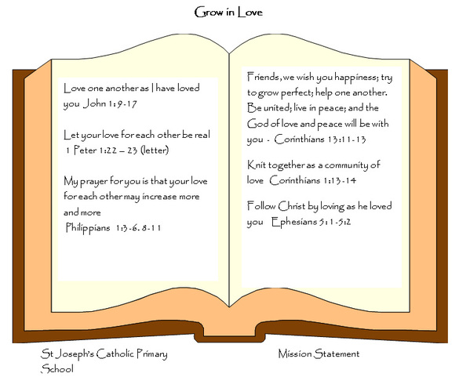
In doing so the school recognises the importance of establishing a successful partnership between itself, the home and the Parish, and the development of a relationship with the local and wider community.

SCHOOL’S EDUCATIONAL RESPONSIBILITIES

We acknowledge our responsibility to support parents in their task of nurturing their children towards human wholeness within a Christian community.
Therefore the school will/try to
- Provide a friendly welcome to your child and a secure, stimulating, Catholic environment in which to learn.
- Ensure that your child is valued for who he/she is and helped to make good progress in their spiritual, moral, emotional and academic development.
- Treat your child with the dignity and respect they require, encouraging them to full human wholeness.
- Demonstrate our faith and our school’s Catholic foundation in the teaching of Jesus Christ, by what we teach and the way we live and worship in our school.
- Do our utmost to provide the best possible education we can for your child and enthusiastic teaching rooted in our Catholic beliefs, our values and our skills.
- Provide you with information about your child’s progress and provide you with the opportunities to talk to teachers.
- Keep you informed about school policies and activities via meetings, letters etc.
- Set, mark and monitor homework suitable to your child’s progress.
- Send home an annual report of your child’s progress.
- Contact you if there is a problem with your child’s attendance or punctuality.
- Inform you of any concerns regarding your child’s behaviour, work or health.
- Challenge your child to strive for the highest standard of personal, social and intellectual development and aim for excellence in all they do.
- Support and encourage your child to develop responsibility for their own learning.
- Have regard to the duty we owe your child to report any concerns to outside agencies.

PARENTAL RESPONSIBILITIES

We acknowledge that we as parents are the primary educators of our children and have an irreplaceable role to play in supporting our children’s learning in school.
Therefore I/we will try to: -
- Recognise and respect the distinctive Catholic ethos and education the school provides and its importance to the school community
- Ensure that my child attends school regularly, on time and suitably equipped. Unless my child is ill, I understand that all absences will be recorded as unauthorised. In exceptional circumstances, permission may be granted by the Headteacher.
- Whenever possible not take holidays during term time.
- Inform the school of any concerns or problems that might affect my child’s work or behaviour.
- Give my child opportunities for home learning and support homework from the school.
- Support the school’s policies and guidelines for behaviour.
- Attend Parents’ Evening and discussions about my child’s progress.
- Encourage my child to be enthusiastic about learning and to enjoy school.
- Encourage my child to show kindness and consideration to others.
- Talk to my child about their experiences in school and encourage them to do their best.
- Attempt to support the Catholic community and the school governors in their responsibilities for maintaining the school buildings in good repair.

Signed: ___________________________________________

Parent / Guardian: ____________________________________________

PUPIL RESPONSIBILITY

I acknowledge the different and unique talents which God has given me, and my responsibility to use them wisely.

Parents / Guardians please read and discuss with your child
- Attend school regularly.

- Wear the school uniform and bring all equipment I need every day.

- Take care of all school equipment and help keep our school free from litter.

- Learn something new each lesson and always do my best

- Share my feelings honestly and politely and show consideration for others in school.

- Behave sensibly so we can be happy and safe as we learn.

- Try to think for myself and take responsibility for my actions.

- Observe all school rules and treat everyone with the respect they deserve.

Signed: _______________________________________
(Pupil - Year 3 onwards)

