Level 2
PROMPT sheet

2/1 To count by grouping

Example1: Here are 20 sweets to share
Each child gets 5 sweets
How many children are there?

Divide them up into groups of 5 sweets-like this

There must be 4 children

Example2: Here are 12 marbles to share
There are 4 children.
How many marbles does each get?

Divide them up into 4 groups - like this

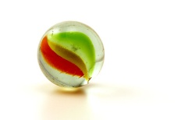

Each child gets 3 marbles

2/2 To order numbers

Numbers can be ordered by looking at the value of each digit
Example:
To order 83 3 87 8 80 78
Tens Units
T U
8 3
0 3
8 7
0 8
8 0
7 8
The order would be;
3 8 78 80 83 87
smallest largest

2/3 Numbers sequences

Look to see what you already know
Example1: 1 4 7 10 ..... .....
+3 +3 +3
- The numbers are going up- ascending
- They go up by 3 each time
- Continue with this rule

1 4 7 10 13 16
+3 +3

Example1: 13 11 9 7 ..... .....
-2 -2 -2
- The numbers are going down - descending
- They go down by 2 each time
- Continue with this rule-count backwards
13 11 9 7 5 3
-2 -2

2/4 Know the 2, 5, 10 times tables

1 | x | 2 | = | 2
2 | x | 2 | = | 4
3 | x | 2 | = | 6
4 | x | 2 | = | 8
5 | x | 2 | = | 10
6 | x | 2 | = | 12
7 | x | 2 | = | 14
8 | x | 2 | = | 16
9 | x | 2 | = | 18
10 | x | 2 | = | 20
1 | x | 5 | = | 5
2 | x | 5 | = | 10
3 | x | 5 | = | 15
4 | x | 5 | = | 20
5 | x | 5 | = | 25
6 | x | 5 | = | 30
7 | x | 5 | = | 35
8 | x | 5 | = | 40
9 | x | 5 | = | 45
10 | x | 5 | = | 50

1 | x | 10 | = | 10
2 | x | 10 | = | 20
3 | x | 10 | = | 30
4 | x | 10 | = | 40
5 | x | 10 | = | 50
6 | x | 10 | = | 60
7 | x | 10 | = | 70
8 | x | 10 | = | 80
9 | x | 10 | = | 90
10 | x | 10 | = | 100

2/5 Work out halves and quarters

To work out a half
Split into two equal parts
YES NO!!!!
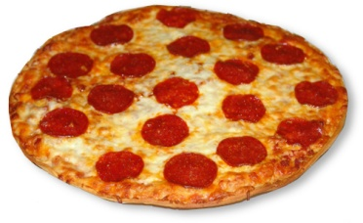

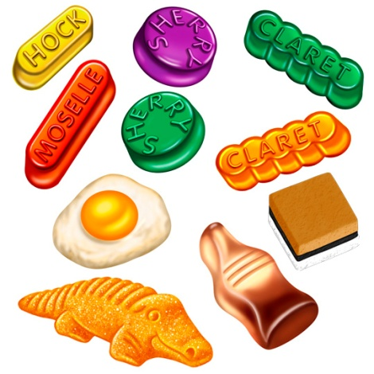

10 sweets ÷ 2 = 5 sweets
To work out a quarter
Split into four equal parts

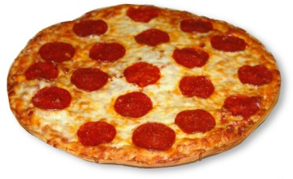

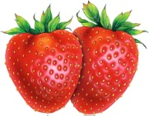

8 strawberries ÷ 4 = 2 strawberries

2/6 Subtraction is the inverse of addition

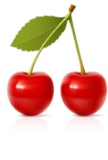
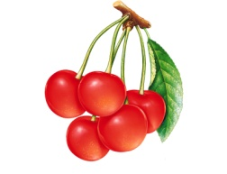
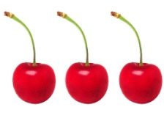
=
+

3 + 2 = 5

-

5 - 2 = 3
-

5 - 3 = 2

Matching subtraction facts for an addition sum

3 + 2 = 5

- - 2 = 3 5 - 3 = 2

- + 4 = 10

10 – 6 = 4 10 – 4 = 6

2/7 Halving as a way of undoing doubling

3 DOUBLE 6
5 10

3 HALF 6
5 10

2/8 Number bonds (Friends) to 10

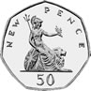
 |  |  |  |  |  |  |  |  | 10
1 |  |  |  |  |  |  |  |  | 9
 | 2 |  |  |  |  |  |  |  | 8
 |  | 3 |  |  |  |  |  |  | 7
 |  |  | 4 |  |  |  |  |  | 6
 |  |  |  | 5 |  |  |  |  | 5
 |  |  |  |  | 6 |  |  |  | 4
 |  |  |  |  |  | 7 |  |  | 3
 |  |  |  |  |  |  | 8 |  | 2
 |  |  |  |  |  |  |  | 9 | 1

0 + 10 | 1 + 9 | 2 + 8 | 3 + 7 | 4 + 6
10 + 0 | 9 + 1 | 8 + 2 | 7 + 3 | 6 + 4
 |  | 5 + 5

These are so good to learn – believe me

2/9 Mental calculation strategies

DOUBLES – you should know all of them
Double 1 (1 + 1) = 2 OR 2 x 1 = 2
Double 2 (2 + 2) = 4 OR 2 x 2 = 4
Double 3 (3 + 3) = 6 OR 2 x 3 = 6
Double 4 (4 + 4) = 8 OR 2 x 4 = 8
Double 5 (5 + 5) = 10 OR 2 x 5 = 10
Double 6 (6 + 6) = 12 OR 2 x 6 = 12
Double 7 (7 + 7) = 14 OR 2 x 7 = 14
Double 8 (8 + 8) = 16 OR 2 x 8 = 16
Double 9 (9 + 9) = 18 OR 2 x 9 = 18
Double 10 (10 + 10) = 20 OR 2 x 10 = 20

Another double
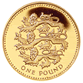
+ =

2/10 Repeated addition (Multiplication)

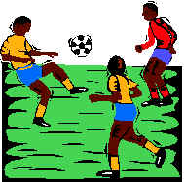
Here are 3 footballers.
How many legs do they have altogether?

Addition sentence Multiplication sentence
2 + 2 + 2 = 6 3 x 2 = 6

Repeated addition is the same as multiplication

Addition sentence | Multiplication sentence
5 + 5 + 5 + 5 = 20 | 4 x 5 = 20
10 + 10 + 10 = 30 | 3 x 10 = 30

2/10 Repeated subtraction (Division)
Repeated subtraction is the same as division

15
This is the same as 15 ÷ 5 = 3

Because 5 has been subtracted 3 times to get to 0
-5 (1)
10
-5 (2)
5
-5 (3)
0

2/11 Solve number problems

- The order can be changed
Example:
13 + 6 + 7 = 13 + 7 + 6 = 20 + 6 = 26

- The number can be partitioned
Example:
10 + 15 = 10 + 10 + 5 = 20 + 5 = 25

- A partial number line can be used
Example:
37 + 8 = 45

⁺⁸
⁺³ ⁺⁵

37 40 45

22 – 3 = 19
⁻¹ ⁻²

19 20 22

2/12 Record work as a number sentence

Example 1
There are 12 people on a bus.
At the next stop 4 people get off and 7 get on
How many are on the bus now?
Number sentence
12 – 4 + 7 = 15

Example 2
Pavan’s cat weighs 18kg. Olivia’s dog weighs 32kg. How much heavier is Olivia’s dog?
Number sentence
32 – 18 = 14

Example 3
Sana had 50p. She spent 24p. How much did she have left?
Number sentence
50 - 24 = 26p

Example 4

Aabid has 20p and Claudia has 41p. How much do they have altogether?
Number sentence
20 + 41 = 61p

2/13 Names of 2D shapes

Triangle Square Pentagon

Hexagon Circle Octagon

2/13 Names of 3D shapes

cube cylinder cuboid
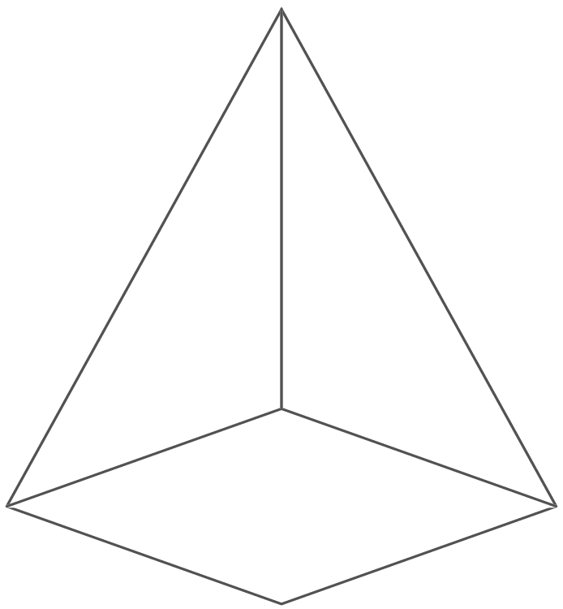
pyramid sphere

2/14 Properties of shapes

corner edge face

curved surface

2/15 Describe position of objects

The yellow square is above the orange cylinder
The sphere is to the left of the pink hexagon
The blue cuboid is below the red circle

2/16 & 17 Describe position of objects

A quarter turn
clockwise

A quarter turn
anti-clockwise

A half turn

2/18 Use measures

METRIC units of length are:
Millimetre (mm)

Centimetre (cm)

Metre (m)

Kilometre (km)

2cm = 20mm 4.5cm = 45mm
1cm = 10mm
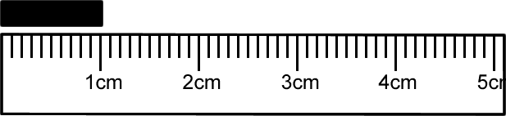

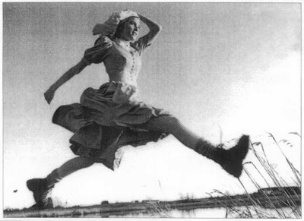

- A big stride is about a metre

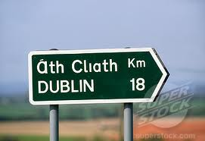

- Distance to Dublin is measured in kilometres

METRIC units of weight are:
Gram (g)

Kilogram (kg)

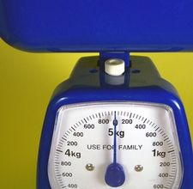

1 kilogram(kg) = 1000grams(g)
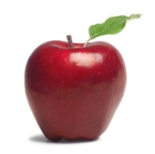

- An apple weighs 150grams

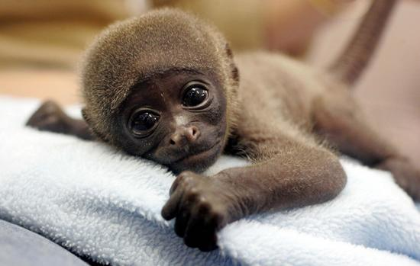

- Baby chimp weighs 3kg

METRIC units of capacity (liquids) are:
Millilitre

Centilitre

Litre

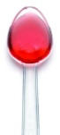
- A medicine spoon holds 5ml

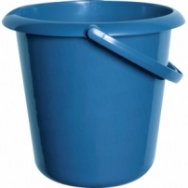
- A 5-litre bucket

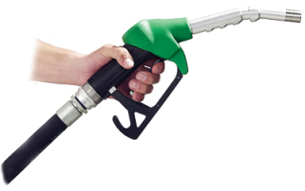
Fuel for the car is measured in litres

2/19 Sorting

Carroll Diagram to sort these numbers:
26 5 14 30 55 8 35 37

 | Multiples of 5 | NOT multiples of 5
Less than 30 | 5 | 26 14 8
NOT less than 30 | 30 55 35 | 37

Venn Diagram to sort these shapes

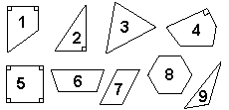
Set R contains shapes with a right-angle (90°).
Set Q contains shapes with four sides.

R Q

6 3
2 1 5
4 7 8
9

2/23 Record & communicate findings
- Frequency table of recycling
Item | Frequency (tally) | Total
Plastic | l l l l 1111 | 10
Glass | 1111 | 4
Cardboard | 1111 1 | 6
Recyclable steel | l | 1
Aluminium cans | l l l l 11 | 7
Other | l l l l 1111 | 9

- Bar chart of animals kept

- Pictogram of football teams

KEY: Each badge represents 2 people

Manchester Utd
Darlington
Liverpool
Newcastle

- Reading the pictogram using the key we have:

Manchester = 6 people
Darlington = 10 people
Liverpool = 3 people
Newcastle = 8 people

